Data Visualization charts Dashboard Creation

|  |  |
| --- | --- |
| Team ID | PNT2022TMID38117 |
| Project Name | Retail Store Stock Inventory Analytics |

# Venda and estoque by data:

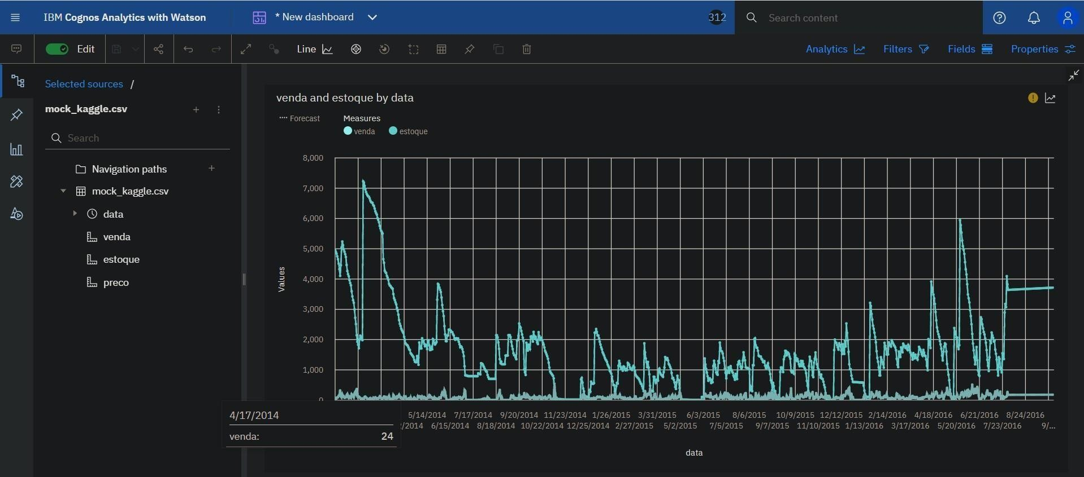

**Venda by Estoque with Points for Data:**

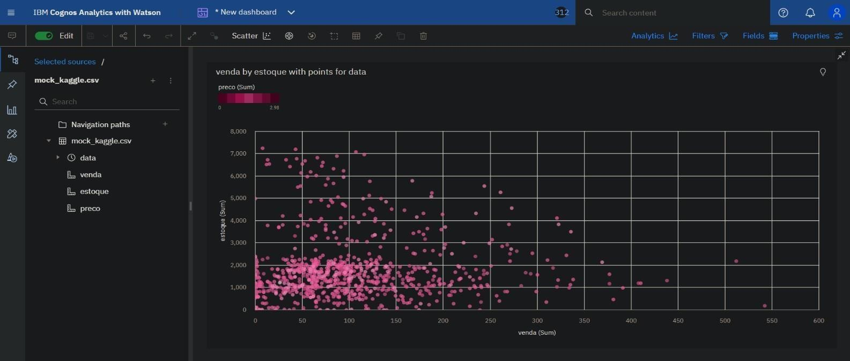

**Estoque colored by Venda and Preco sized by Data:**

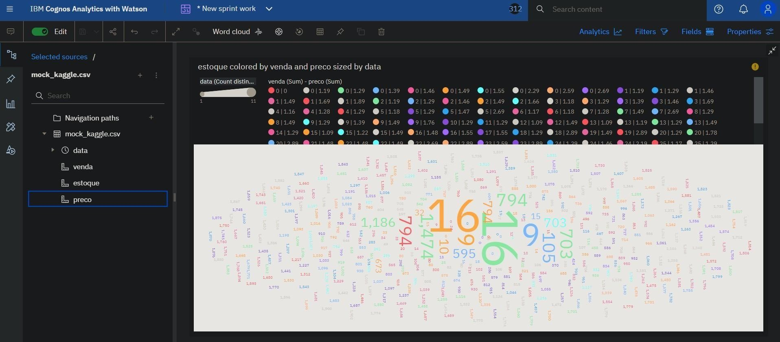

**Preco compared to Data:**

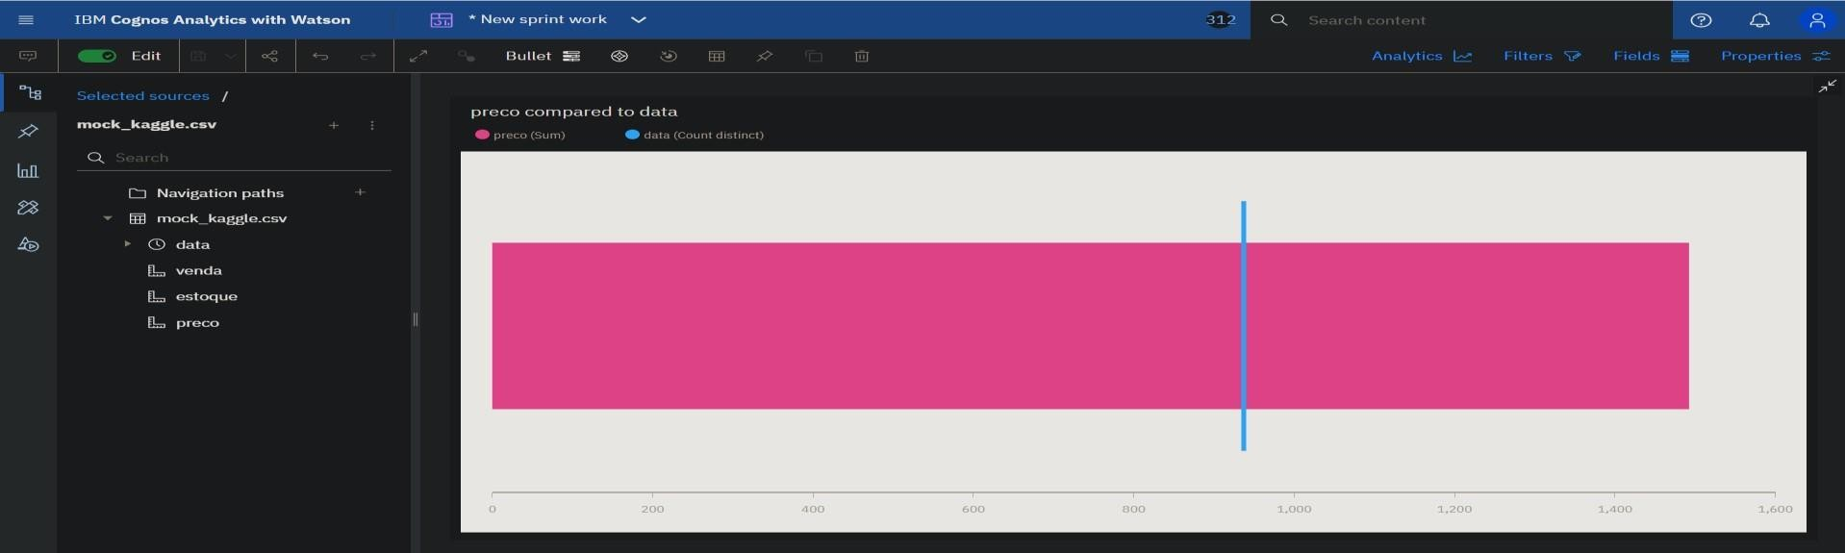

**Estoque by Data:**

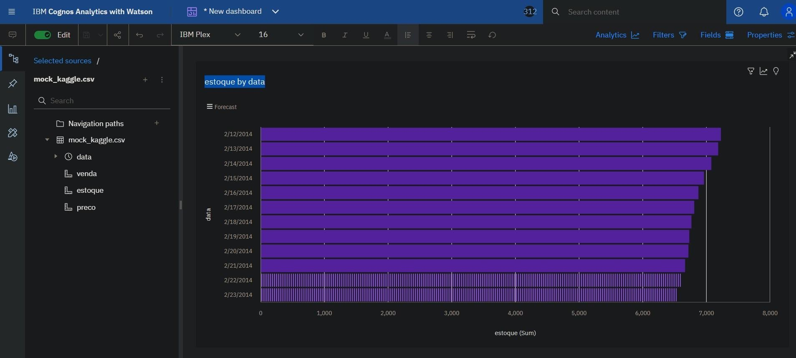

**Preco and Venda by Data:**

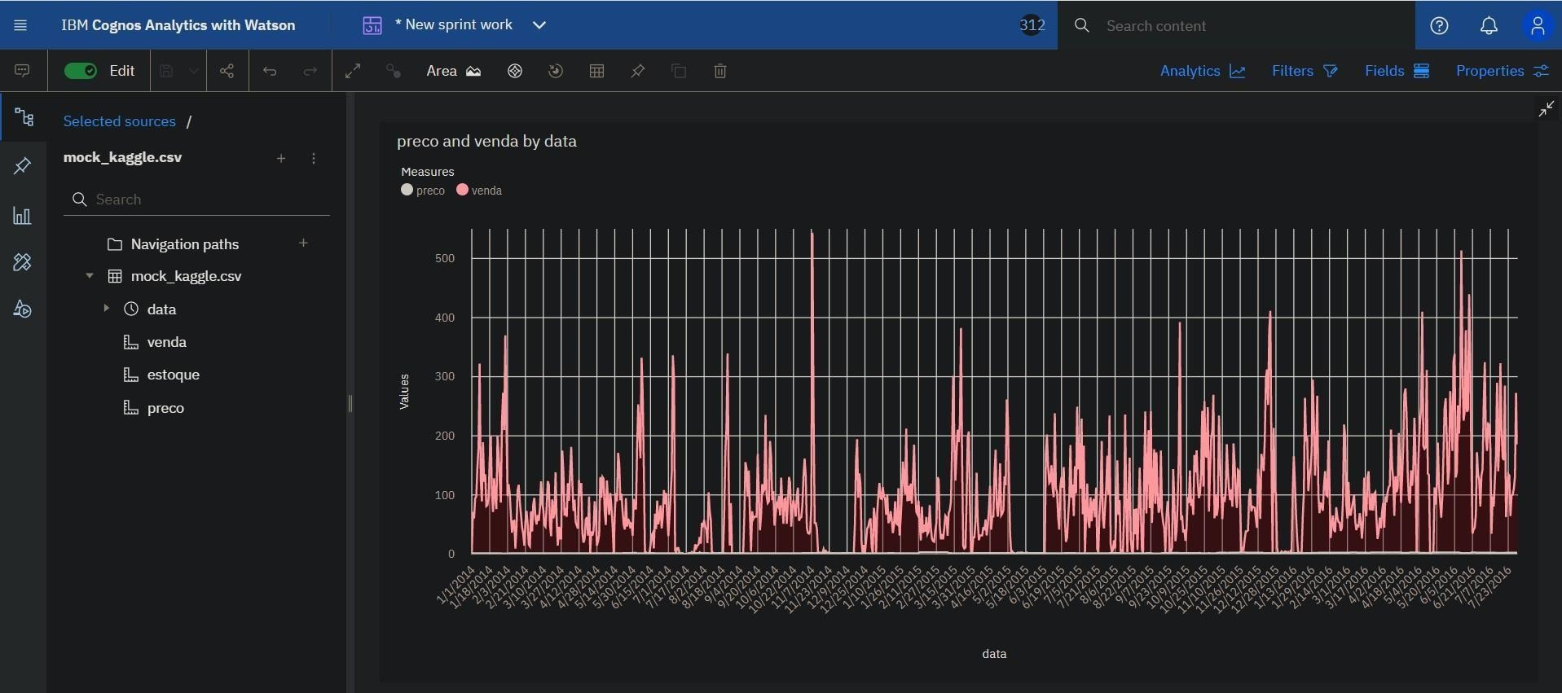

## Data to Venda with Line width Estoque:

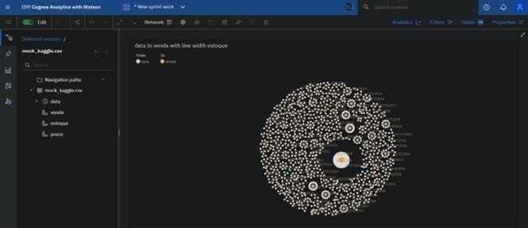

**Link:**

https://us3.ca.analytics.ibm.com/bi/?perspective=dashboard&pathRef=.my_folders%2Fsprint%2Bwo r k%2FNew%2Bsprint%2Bwork&action=view&mode=dashboard&subView=model000001842e9af9 6 2_00000002